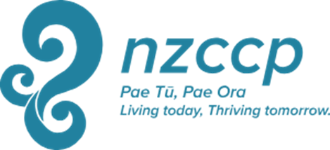

Te Tihi o Manono Award 2024

Please complete all sections of the application form.

- Nominee Details:

Family Name:
--------------------------------------------------------------------------------------------------------------------------------------
First name/s:
--------------------------------------------------------------------------------------------------------------------------------------
Address:
--------------------------------------------------------------------------------------------------------------------------------------

--------------------------------------------------------------------------------------------------------------------------------------
Phone: Email:
--------------------------------------------------------------------------------------------------------------------------------------

- Nominee Information

Please attach:
- Current Curriculum Vitae
- 150 Word Biography
- High Resolution Photo

- Nominee Confirmations

In relation to Te Tihi o Manono Award nomination and Award process:

  - I confirm that I identify as Maori

  - I am a current member of the NZPsS or NZCCP and have been for at least 5 years prior to application

  - I agree to this nomination being submitted

  - I agree that if I am the successful recipient the NZPsS and/or NZCCP will publicise my name, photo and nature of my contribution to indigenous psychology. I accept that I may be contacted in the future for publicity purposes that relate directly to this award.

Nominee’s signature: Date:

4. Nomination information

Nomination must be by Three Full Members of NZPsS and/or NZCCP (or Fellows, etc)

Full name of First nominator
------------------------------------------------------------------------------------------------------------------------------------

Email address:
------------------------------------------------------------------------------------------------------------------------------------

Phone Number:
------------------------------------------------------------------------------------------------------------------------------------

Member of NZPsS or NZCCP

Signature:

Full name of Second nominator:
------------------------------------------------------------------------------------------------------------------------------------

Email address:
------------------------------------------------------------------------------------------------------------------------------------

Phone number:
------------------------------------------------------------------------------------------------------------------------------------

Member of NZPsS or NZCCP

Signature:

Full name of Third nominator:

------------------------------------------------------------------------------------------------------------------------------------

Email address:
------------------------------------------------------------------------------------------------------------------------------------

Phone number:
------------------------------------------------------------------------------------------------------------------------------------

Member of NZPsS or NZCCP

Signature:
------------------------------------------------------------------------------------------------------------------------------------

The nomination must be accompanied by a letter of support stating the nature and extent of the achievements upon which the nomination is based together with copies of representative scholarly (including where applicable, iwi and hapū contributions), and research publications representing significant impact and achievement aligned with the intent of the award

CHECKLIST – We have completed, attached and/or signed the following sections:

- Nominee Details
- Nominee Information
- Curriculum Vitae
- 150 Word Biography
- High-Res Photo of Nominee
- Nominee Confirmations
- Nomination Information
- Details of Full Member 1
- Details of Full Member 2
- Details of Full Member 3
- Written Statement of Support
- Supporting Publications
- 250 Word Citation

Email Application to: Executive Director (NZ Psychological Society)
executivedirector@psychology.org.nz

and

Executive Director, (NZCCP)
Director@nzccp.co.nz

By 1st July, 2024

